**REACT application**

* ~~Create~~ **~~react~~** ~~application using~~ **~~redux~~** ~~for state management.~~
* ~~Application needs to have following pages.~~
* ~~All the page needs to protected except for login / registration, which means if the user is not logged access to Home, Create, List pages needs to be restricted.~~
  + ~~Login~~
  + ~~Registration (provide basic form for registration)~~
  + ~~Home ( Welcome page )~~
  + ~~Create request (page from which requests are created)~~
    - ~~Create page needs to display a prompt message if the user has entered partial data and tries to leave the page.~~
  + ~~List requests~~
    - ~~Page which list all the request created using the create page.~~
    - ~~List page will also have few options.~~
      * ~~Filter list based on the status~~
      * ~~User should be able to change the status from the list page.~~
      * ~~Created / Updated date needs to be in the same format as shown in the wireframe.~~
      * ~~Option for deleting a request from the list page.~~
        + ~~Once delete option is clicked, user should be prompted with a message confirming about the delete action.~~
* You can use bootstrap for styling, if needed.
* ~~All the data needs to stored / retrieved from MongoDB.~~
* ~~Mongodb database needs to have initial data. Please use the json data provided at the end of this document.~~
* Use the wireframe given below for creating the list page.

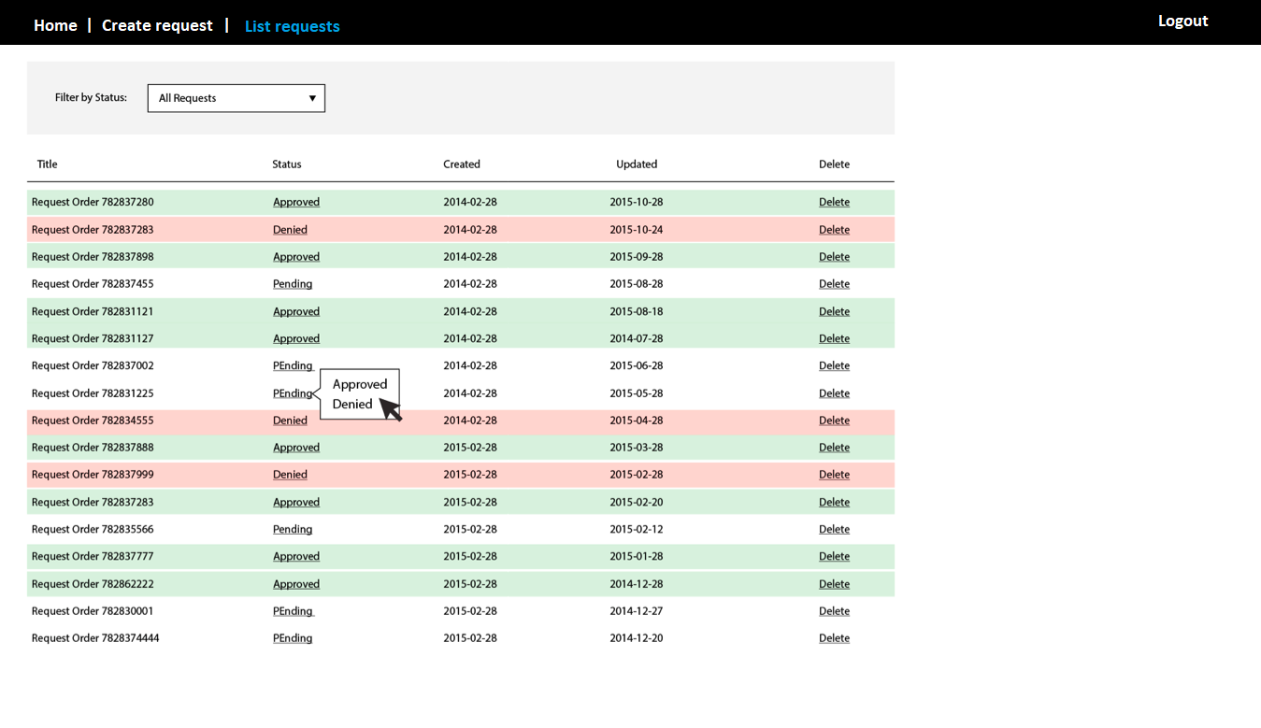

**Also find the json data below.**

[  
 {  
 "id": 1,  
 "title": "Request from Nancy",  
 "updated_at": "2015-08-15 12:27:01 -0600",  
 "created_at": "2015-08-12 08:27:01 -0600",  
 "status": "Denied"  
 },  
 {  
 "id": 2,  
 "title": "Request from David",  
 "updated_at": "2015-07-22 11:27:01 -0600",  
 "created_at": "2015-07-15 12:27:01 -0600",  
 "status": "Approved"  
 },  
 {  
 "id": 3,  
 "title": "Request from Matt",  
 "updated_at": "2015-07-22 11:27:01 -0600",  
 "created_at": "2015-06-15 13:27:01 -0600",  
 "status": "Pending"  
 },  
 {  
 "id": 4,  
 "title": "Request from Perry",  
 "updated_at": "2015-07-15 13:27:01 -0600",  
 "created_at": "2015-07-14 14:27:01 -0600",  
 "status": "Pending"  
 },  
 {  
 "id": 5,  
 "title": "Request from Harrison",  
 "updated_at": "2015-08-22 11:27:01 -0600",  
 "created_at": "2015-07-29 15:27:01 -0600",  
 "status": "Approved"  
 },  
 {  
 "id": 6,  
 "title": "Request from Josh",  
 "updated_at": "2015-07-29 14:27:01 -0600",  
 "created_at": "2015-07-15 10:27:01 -0600",  
 "status": "Denied"  
 },  
 {  
 "id": 7,  
 "title": "Request from Michael",  
 "updated_at": "2015-06-15 12:27:01 -0600",  
 "created_at": "2015-06-13 18:27:01 -0600",  
 "status": "Denied"  
 },  
 {  
 "id": 8,  
 "title": "Request from AJ",  
 "updated_at": "2015-09-22 11:10:01 -0600",  
 "created_at": "2015-07-15 11:27:01 -0600",  
 "status": "Approved"  
 },  
 {  
 "id": 9,  
 "title": "Request from Jane",  
 "updated_at": "2015-09-13 11:18:01 -0600",  
 "created_at": "2015-09-10 06:27:01 -0600",  
 "status": "Approved"  
 },  
 {  
 "id": 10,  
 "title": "Request from Jizhen",  
 "updated_at": "2015-05-12 08:27:01 -0600",  
 "created_at": "2015-04-15 06:27:01 -0600",  
 "status": "Pending"  
 },  
 {  
 "id": 11,  
 "title": "Request from Pardeep",  
 "updated_at": "2015-07-28 09:27:01 -0600",  
 "created_at": "2015-07-17 05:27:01 -0600",  
 "status": "Approved"  
 },  
 {  
 "id": 12,  
 "title": "Request from Ale",  
 "updated_at": "2015-07-22 10:27:01 -0600",  
 "created_at": "2015-07-18 15:27:01 -0600",  
 "status": "Pending"  
 },  
 {  
 "id": 13,  
 "title": "Request from Christy",  
 "updated_at": "2015-04-22 19:27:01 -0600",  
 "created_at": "2015-03-15 16:27:01 -0600",  
 "status": "Pending"  
 },  
 {  
 "id": 14,  
 "title": "Request from Surjadeep",  
 "updated_at": "2015-07-01 11:27:01 -0600",  
 "created_at": "2015-06-29 17:27:01 -0600",  
 "status": "Approved"  
 },  
 {  
 "id": 15,  
 "title": "Request from Vasanth",  
 "updated_at": "2015-07-02 11:27:01 -0600",  
 "created_at": "2015-07-01 18:27:01 -0600",  
 "status": "Approved"  
 },  
 {  
 "id": 16,  
 "title": "Request from Moshe",  
 "updated_at": "2015-01-22 16:27:01 -0600",  
 "created_at": "2014-12-25 11:27:01 -0600",  
 "status": "Denied"  
 },  
 {  
 "id": 17,  
 "title": "Request from Jim",  
 "updated_at": "2015-10-22 17:27:01 -0600",  
 "created_at": "2015-10-15 13:27:01 -0600",  
 "status": "Approved"  
 },  
 {  
 "id": 18,  
 "title": "Request from Dileep",  
 "updated_at": "2015-08-18 18:27:01 -0600",  
 "created_at": "2015-07-11 12:27:01 -0600",  
 "status": "Denied"  
 },  
 {  
 "id": 19,  
 "title": "Request from Aaron",  
 "updated_at": "2015-06-22 19:27:01 -0600",  
 "created_at": "2015-05-28 16:27:01 -0600",  
 "status": "Approved"  
 },  
 {  
 "id": 20,  
 "title": "Request from Vijay",  
 "updated_at": "2015-02-14 08:27:01 -0600",  
 "created_at": "2015-01-02 12:27:01 -0600",  
 "status": "Approved"  
 }  
]